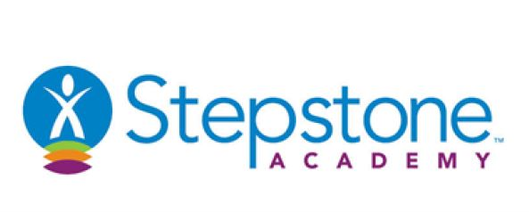

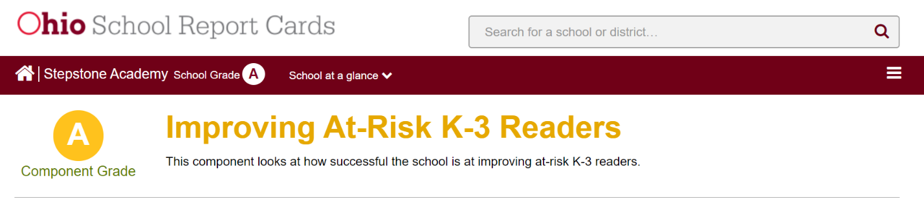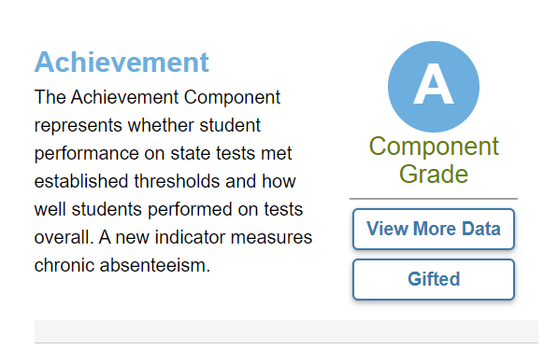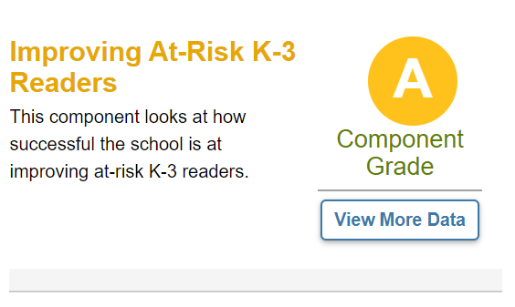

**Non Operating Receipts**

**Federal Grants**

$                                384,000

**Other Local Receipts**

$                                187,000

**Donations**

$                                  97,000

**Debt Principal**

$                                595,000

**Total**

$                            1,263,000

**Net Operating Receipts/Disbursements**

$                          (1,394,000)

**Excess Receipts/Disbursements**

$                             (131,000)

**Operating Receipts**

**State Foundation**

$                                873,000

**Other**

$                                  10,000

**Total**

$                                883,000

**Operating Disbursements**

**Salary, Wages, Benefits**

$                            1,252,000

**Purchased Services**

$                                902,000

**Other**

$                                123,000

**Total**

$                            2,277,000

At Stepstone Academy, we do understand there are many important measures of success and we are encouraged by the progress we have made. Our overall Ohio report card grade is an “A.” We are proud to be the highest performing school in Cleveland’s Central Neighborhood.

Following is a snapshot of our data:

Many of our students enter school needing significant development in their literacy skills; without intervention, they are likely to struggle with reading comprehension in later grades. With our newly implemented literacy programming we have seen significant gains in student growth. We expect to continue this trend over the coming years as a result of our commitment to improving literacy for all students at Stepstone Academy.

Jim Dombrowski- Superintendent

**Annual Report**